IDL package pack_MMS_cocurldiv

P. Robert, December 7, 2015
Revised January 25, 2016
______________________

The package include :

1) two main crib sheets :
- crib_MAIN_mms_curlometer_tplot.pro
- crib_MAIN_mms_curlometer_crefiles.pro

crib_MAIN_mms_curlometer_tplot.pro allow to :
- load magnetic field and position, time aligned, at the 4 vertice of the MMS tetrahedron
- compute following quantities : Dij, J_cur, Div, Div_Curl, JxB_Norm, JB_Angle
- plots the results via tplot variables. An example is given figure 1.

crib_MAIN_mms_curlometer_crefiles.pro allow to:
- load magnetic field and position, time aligned, at the 4 vertice of the MMS tetrahedron
- create 4 ascii files containing header and data with the 'addvecpos_N.resu' compatible with the Roproc software. Allow the comparison between the results of the cocurldiv sofware (in IDL) and the Roproc software (in F90).

2) a series of 'sub' crib:
The main crib sheets needs some 'include' crib given below:

crib_check_data_alignment.pro
crib_check_data_size.pro
crib_compile_mms_curlometer_crefiles.pro
crib_compile_mms_curlometer_tplot.pro
crib_mag_and_pos_time_alignment.pro
crib_make_arrays_for_curlometer.pro
crib_tplot_option_for_curlometer.pro

$namepack

3) a series of operating procedures:
To run, theses crib also requires the following IDL procedures:

cocurldiv.pro
cointdist.pro
create_magpos_file.pro
cangrat.pro
datim_iso.pro
mms_init.pro
barycentric_lib.pro

4) some 'time' procedures for ISO date management:

tu_datesec.pro
tu_julsec_to_isodatea.pro
tu_julsec_to_isodate.pro
tu_secdate.pro
tu_secday_to_strtime.pro

5) directories provide

a) Tdas software:

general.tar.gz
spdsw_r19402_2015-11-17.tar.gz
DATA_MMS.tar.gz

Note that line 107 of the the mms_init.pro located in
./spdsw_r19402_2015-11-17/idl/projects/mms/common/mms_init.pro
has been commented to avoid a 'splash' message.

b) Results of crib_MAIN_mms_curlometer_tplot.pro

results.tar.gz

This directory contains PS and PNG files.

c) Results of Roproc cocurldiv procedure

test_Roproc.tar.gz

This directory contains files addvecpos_N.resu ( N=1, 2, 3, 4) created by crib_MAIN_mms_curlometer_crefiles.pro, and the curlometer computation made by the Roproc sofware. Usefull to test the validity of the IDL package. Tests have benn done and are successful.

6) Revision of January 2016

A calibrated tplot variable JXB, in mV/m, has been added. For this computation, a density of N=1.6 electron/m3 has been assumed.
Current density J is now in nA/m2.

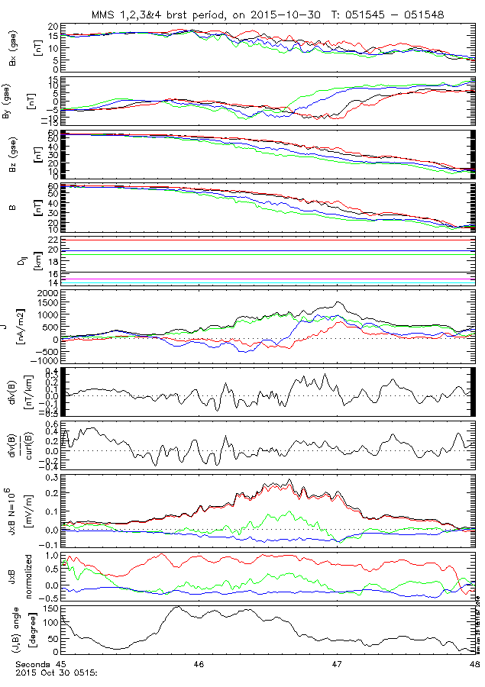

Figure 1: plot example provided by 'crib_MAIN_mms_curlometer_tplot.pro'

